Computer Shop System

Use-Case Specification: Delete staff profile

Version 1.0

Revision History

|  |  |  |  |
| --- | --- | --- | --- |
| **Date** | **Version** | **Description** | **Author** |
| 15/12/2019 | 1.0 | details | Hoang Trung Hieu |
|  |  |  |  |
|  |  |  |  |
|  |  |  |  |

Table of Contents

1. Use-Case Name 3

1.1 Brief Description 3

2. Flow of Events 3

2.1 Basic Flow 3

2.2 Alternative Flows 3

2.2.1 < First Alternative Flow > 3

2.2.2 < Second Alternative Flow > 3

3. Special Requirements 3

3.1 < First Special Requirement > 3

4. Preconditions 3

4.1 < Precondition One > 3

5. Postconditions 3

5.1 < Postcondition One > 3

6. Extension Points 3

6.1 <Name of Extension Point> 3

Use-Case Specification: Delete staff profile

# Use-Case Name

## Brief Description

This use case show steps of remove staff from database. The system allows computer store managers to delete a staff.

# Flow of Events

## Basic Flow

First, Computer store managers click on delete staff button. The system will show on screen a notification to confirm that Computer Store managers want to delete whether or not. If click on “YES” button, the system will remove the staff from dataset. Otherwise, the delete action will not be executed.

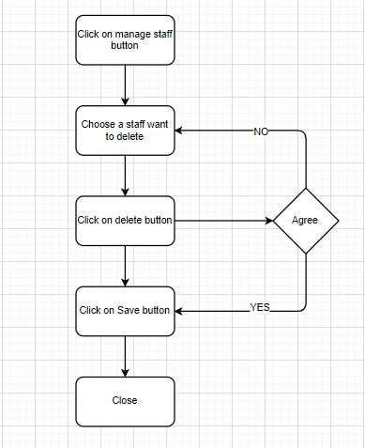

# Special Requirements

Computer store manager must know how to use management system.

# Preconditions

Manager need to log in system and select profile management function.

# Postconditions

The deleted staff must be removed from database

# Extension Points

None.